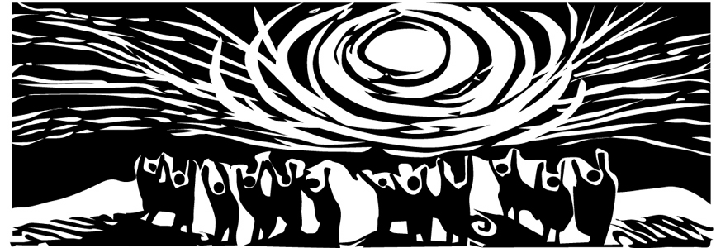
Survivors Network of those Abused by Priests

His Holiness Pope Benedict XVI PP
Apostolic Palace
Via Del Pellegrino
Citta Del Vaticano 00120
Vatican City State

In care of:
Most reverend Pietro Sambi,
Apostolic Pro-Nuncio,
3339 Massachusetts Ave., NW,
Washington DC 20005

Jan. 9, 2008

Dear Holy Father:
We are members of a confidential self-help group for men and women who have been sexually abused by clergy (Catholic and otherwise). Our goals are to help heal the wounded and protect the vulnerable. We join with other Catholics who believe that our Church needs to be a visible witness to the healing of survivors.
We write because of your upcoming trip to the US and the on-going clergy sex abuse and cover up scandal. Specifically, we write to propose a simple but meaningful step you could take in the weeks ahead to help ease the suffering of thousands of Catholics, ex-Catholics, and child molestation victims.
The continued high-profile status and influence of Cardinal Bernard Law, in the literal and figurative center of Catholic power, rubs even more salt into the still fresh and very deep wounds of thousands. Regardless of how one characterizes his motives, for years and years, Cardinal Law’s actions have clearly led to immense and largely preventable devastation to the lives of hundreds of once trusting and innocent and vulnerable children, their loved ones, the Boston Catholic community, and indeed, across the US.
As you know, he sits on eight important Vatican dicasteries, and has a particularly troubling, powerful role in the selection of new bishops. This, coupled with his increasing public visibility, again exacerbates intense pain among many.
We respectfully ask that you insist that Cardinal Law honor the mandatory retirement age for bishops and step down before you visit the US this spring. A more clear, simple and effective step could better ease our suffering is hard to imagine. And without this step toward basic justice and accountability, other gestures you or other church officials might take regarding clergy sex crimes and cover ups will ring hollow. “It’s time to forgive,” some might say. Many have already forgiven him. But forgiveness toward a wrong-doer doesn’t mean callousness toward the innocent. Forgiveness also doesn’t guarantee a sinner promotions and unfettered access to power, especially when those moves add to an already overwhelming reservoir of still-unaddressed sadness and suffering among victims and the laity.
“Why shouldn’t Cardinal Law be allowed to contribute to the church?” others might ask. Because, simply, his comfort and convenience are secondary. The well-being of those in deep pain should come first. (And one might legitimately question how helpful HE can be in choosing bishops since, by his own admission, he repeatedly erred in serious personnel issues in Boston involving dangerous predators in the priesthood.)
We are grateful for the recent Vatican initiative to encourage more widespread prayer by Catholics across the world focused on this crisis and its victims. We welcome nearly any effort to raise public awareness of the scandal, especially one that reminds us all that so many who’ve been assaulted and betrayed are still in deep pain. This action on your part will represent a powerful complement to you recent call for prayer.
At the same time, however, words alone won’t heal these deep and on-going wounds. Hundreds of complicit bishops have either largely ignored or concealed horrific crimes against vulnerable kids. None of those complicit bishops have experienced any consequences for this. No genuine healing, we feel, can take place without this injustice being addressed.
We urge you to listen to the voices of those who have suffered, and continue to suffer, from this terrible wound to the Church.
Barbara Blaine, President of SNAP
David Clohessy, National Director of SNAP
Mary Grant, Western Regional Director for SNAP
Peter Isely, Midwest Regional Director for SNAP
Mark V. Serrano, Mid-Atlantic Regional Director for SNAP
Barbara Dorris, Outreach Director for SNAP
In support of this letter,
Mary Pat Fox, President Voice of the Faithful
Survivors Network of those Abused by Priests
700 North Green, Suite 504 Chicago, Illinois 60622

Voice of the Faithful
P.O. Box 423, Newton MA 02464

